**Android Basics**

**Android App Basics**

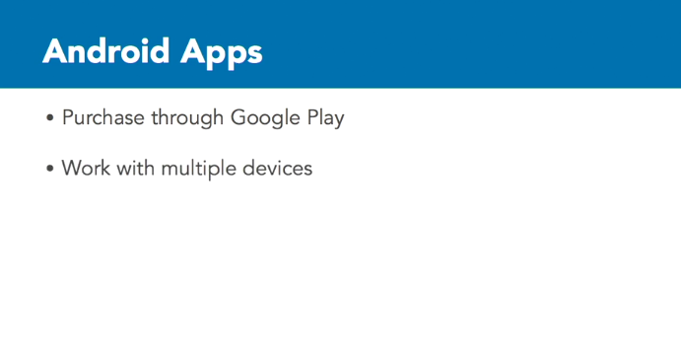

Let's take a step back and look at Android apps in general first before we go into the details of the tools you're going to work with. Android apps are apps that you can purchase through the Google Play store, or through Amazon if you publish for Fire devices. You can build apps for multiple devices. These apps all run Android include tablets, smartphones, supported Chrome OS devices, Android TV, Android Auto, and Android Wear. The app that we are going to build will work on Android-powered smartphones, tablets, and supported Chrome OS devices.

It'll share our common interface, so we can interact with on all of these various devices. I say can work, because we won't customize the interface to work uniquely for each device, but the app will work and run on each of these devices. The version of Android we will target in this course is Ice Cream Sandwich. Android versions are named after desserts. The newest version of Android currently available is Nougat. Each version starts with the next letter in the alphabet. So, after Ice Cream Sandwich is Jelly Bean, then KitKat, then Lollipop, then Marshmallow, and then finally, Nougat.

We are targeting Ice Cream Sandwich, because it will work with a wide variety of devices. Android versions can take time to proliferate on devices throughout the world, and Ice Cream Sandwich, or ICS, is compatible with almost 97% of Android devices worldwide. The exercise files are already configured to work with the Android SDK for Ice Cream Sandwich called API level 15, but if you create the exercise files from scratch, you can work with newer APIs if you wish. But if you're using your own hardware to test your app, make sure you have the right version installed to support the API level you select.

